BioSIM 11 Start up


Jacques Régnière
Rémi Saint-Amant
Ariane Béchard

2017

Natural Resources Canada
Canadian Forest Service
Laurentian Forestry Centre
P.O. Box 10380, Stn. Sainte-Foy
Quebec, QC Canada, G1V 4C7
1 Introduction 3
1.1 Main interface 4
2.2 Creating a project 6
2 Example 1 7
Step 1: Defining a group of components 7
Step 2: Defining a Weather Generation 7
Step 3: Defining Model Execution 10
Step 4: Defining an analysis to interpret the results 11
Step 5: Adding a component onto another component 13
Step 6: Exporting the results 15
3 Example 2 16
Step 1: Defining a new group of components 16
Step 2: Defining a new simulation 16
Step 3: Defining an average output analysis 17
Step 4: Defining and running an event extraction analysis 17
Step 6: Running the checked components 18
Step 7: Adding a graph 19
4 Example 3: Mapping 21
Step 1: Defining a Weather Execution and Model Execution 21
Step 2: Defining a subset analysis 22
Step 3: Defining a mapping 22
Step 4: Run All 23
Step 5: Viewing the R² cross-validation results 23
Step 6: Viewing the maps 24
5 Example 4: Update current daily database 25
Step 1: Adding a new Subgroup of components 25
Step 2: Defining a Update weather data 25
Step 3: Defining a weather generation and model execution 26
Step 4: Defining an output analysis 26
Step 5: Defining an function Analysis 27
Step 6: Defining a mapping 27
Step 7: Run and Viewing the maps 27

1 Introduction

This tutorial’s objectives are (1) to give the BioSIM user a general overview of the software’s main capabilities, and (2) to illustrate the sequence of actions normally involved in using the software.

NOTE: In this tutorial, it is assumed that BioSIM was installed in the default directory:
C:\Program Files\NRCan\BioSIM\.

If this is not the case, replace the default directory by the actual directory where BioSIM was installed on your computer.

If you whish to skip the initial setup described below and simply understand the examples, an entire demo sub-directory entitled \DemoBioSIM\ containing the same fictional project can be found in the \Examples\ directory allowing you to get better acquainted with the software without having to carry out all the steps needed to set it up yourself. The \Examples\ directory is always installed in the same directory as the \BioSIM\ directory.

Because the average user does not have writing privileges in the \Program Files\ directory, it is strongly recommended to copy the \DemoBioSIM\ sub-directory under a working directory such as C:\BioSIM Projects\.

By default, BioSIM is provided with a North American Normals database (Canada-USA 1981-2010). However, several other Normals databases (Central and South America, Europe and the World) are available at:

ftp://ftp.cfl.scf.rncan.gc.ca/regniere/Data11/Weather/Normals/.

Databases taking into account climatic change predictions are available at:

ftp://ftp.cfl.scf.rncan.gc.ca/regniere/Data11/Weather/Normals/ClimaticChange.

Several Daily databases are available at:

ftp://ftp.cfl.scf.rncan.gc.ca/regniere/Data11/Weather/Daily/.

Several Hourly database are available at:

ftp://ftp.cfl.scf.rncan.gc.ca/regniere/Data11/Weather/Hourly/.

NOTE: A Canadian Daily database containing weather data for the last 2 years is also available and is updated frequently (usually daily).

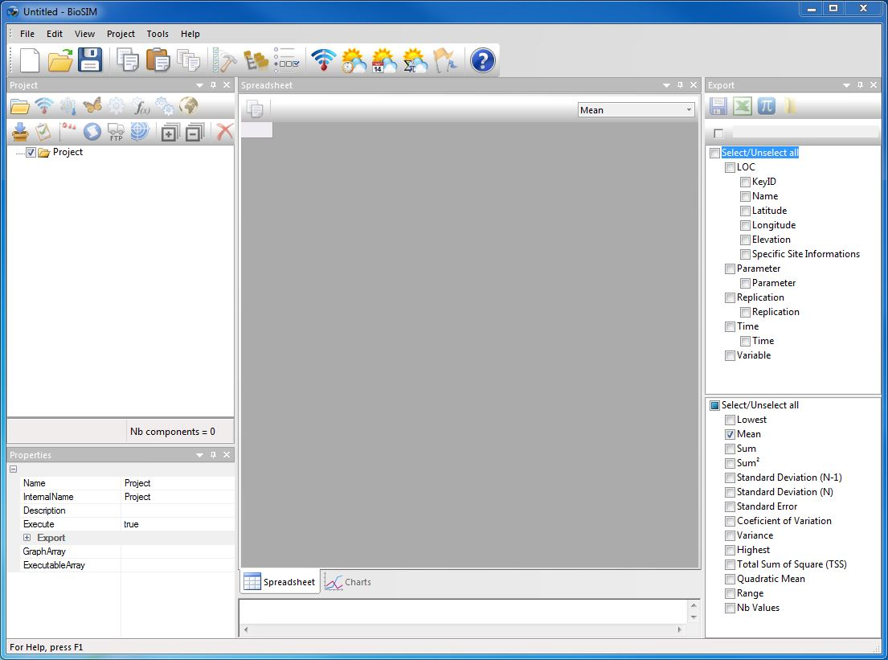
1.1 Main interface
Main window:
Show the results of the selected component.
Data tab: table representation
Graph tab: graphical representation
Export window: Send the results of the current component outside of BioSIM. Select the variables and the statistics to be exported.
Properties window:
Show the properties of the current component.
Execute Message Log window:
Show notifications concerning the last execution.
Project window: Add a new component to the project.
Project window: Add a new component to the project

The main window of BioSIM is composed of 2 tabs: Data and Graph. There are 4 secondary windows docked to the main window: Project, Properties, Execute Message Log and Export that can be moved around and closed at will.
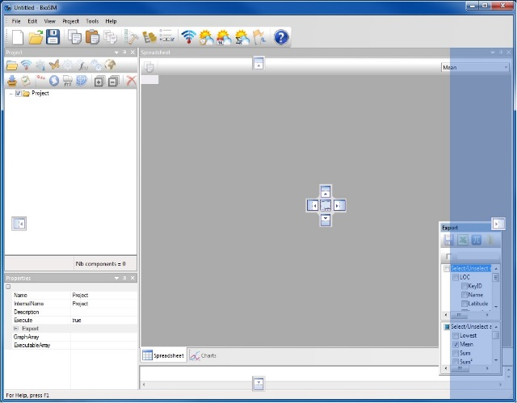
The 4 secondary windows can be configured by the user. When a secondary window is moved/dragged using the mouse, two pictograms appear on screen; one surrounding the main window, and one in either the main window (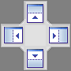), or in whichever secondary window (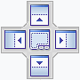) you are attempting to drag the first secondary window. These pictograms will highlight the area where the secondary window currently being dragged will be docked once it is released. The secondary windows can also be left free (undocked).

All secondary windows can be grouped together in a single window docked to the main window and become accessible as tabs in this window.

To reopen a secondary window once it has been closed, select [View] and then [Toolbars and Docking Windows] from the menu bar.

The Project window lists all the components of a project, it is through this window that you can add, remove and edit project components. All tabs and windows in BioSIM are linked to the component selected in the Project window. A project is composed of a set of components that can be grouped together in sub-sets. When a component is selected in the Project window, all other tabs and windows will be updated with the information concerning this component.

When a component is executed, using the Execute Checked  button on the main window’s toolbar, the Data tab in the main window will show the numerical results of the component in question while the Graph tab will allow you to create and then display graphs of these same results.

The Properties window shows the internal parameters of the component. The Execute Message Log window shows the last execution notifications. The Export window shows all the variables that where selected for export (regardless of their dimension).

The following is a list of the various components that can be added to a project by clicking one of the following buttons on the first row of the Project window’s toolbar.

- Group: Used to easily group components into sub-projects.

Weather Updater: Used to Download Weather data to update Weather data of a project.

Weather Generation: used to generates weather (hourly, daily) from observations (hourly, daily) or stochastic disaggregation or a mix of both.

Simulation: Creates weather for locations and executes models to transform weather into model-specific output (models are in fact external dll’s or exe’s). For example, a spruce budworm model transforms weather into spruce budworm life-stage development.

Analysis: Based on the output of another component (simulation, analysis, etc.), this creates a subset of the results of this component and/or extracts information such as time transformations, events or statistics.

Function Analysis: Executes row calculations based on a formula.

Merge: Merges several components of a group to create a single component.

Mapping: Adds a mapping component to a parent component (e.g. on a simulation, an analysis, a function analysis, etc.). Performs spatial interpolations to create maps from data points.

Import File: Imports a simulation from an external file.

Weather input Analysis: Can only be performed on a simulation, is used to examine weather information.

Dispersal: Used to simulate the dispersal of an insect in the wind. Only Choristoneura fumiferana is available.

Script: Used to call an external application (like R) with a file in the output directory.

Copy Export: Used to copy export file to an other directory or an ftp site.

Model Calibration: Allows using the parameters of a model using «Simulated Annealing».

An unlimited number of child components can be added to parent components allowing you to create chains of varying length and composition within each project. However, depending on the nature of the parent component, it is possible that only certain types of child components can be added (for detailed explanations and examples please refer to the manual).

Creating a project

The first thing you must do in BioSIM is create a project.

To create a new project, click on [File] and then [Save As…] in the menu bar.

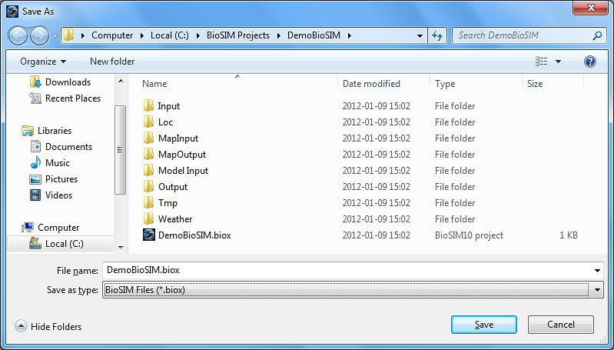
Select a directory in which to save your project. It is recommended to create a new directory when saving a new project, as BioSIM will automatically generate several new sub-directories whenever a new project is created. For example, create a directory with a name such as DemoBioSIM and name the file DemoBioSIM.biox (if you omit the file extension, it will automatically be assigned a .biox extension). All the information related to this tutorial will now be stored in this project directory.

2 Example 1
The objective of the first example is (1) to show you how to create a simulation using historical weather data from 2008 to 2010 and (2), to show you how to extract, export and graph some climate variables.

Step 1: Defining a group of components
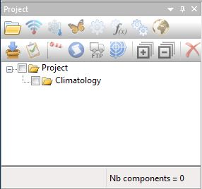
1-To add a component into another, you must first select the parent component.
2-Then, click on the add component button that lets you add the appropriate type of child component.
In the Project window, select the “Project” folder icon and then click the Add Group button on the first row of the Project window’s toolbar, or select [Project] and then [Add Group] from the menu bar. This will add a group to the “Project”.

Select the “Group” component you just created, click on it a second time and rename this group Climatology.

Step 2: Defining a Weather Generation

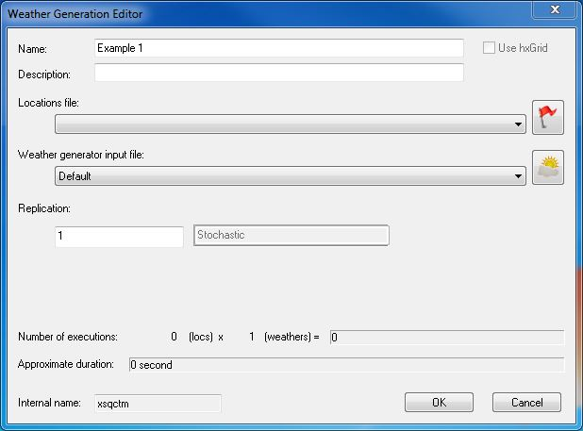
Select the “Climatology” group you just created and click the Add Weather Generation button on the first row of the Project window’s toolbar, or select [Project] and then [Add Weather Generation] from the menu bar.

This will open the Weather Generation Editor dialog with which a new Weather Generation can be defined.

Type Example 1 in the Name field, this name will appear in the Project window.

If you wish, you can type in a description of the simulation being defined in the Description field. This description will appear in the Execute Message Log window once the component has been executed.

Then click on the button. This will open two dialogs; the first dialog is the Location File Editor while the second is the Location List Editor.

In the Location File Editor dialog, click the New button and type in Specific Locations as the name of your new location list. A new file with the name Specific Locations.csv will be created under the \Loc\ sub-directory of the project. This file is in Coma-Separated Values (CSV) format and contains a header line with the following column names: Name, ID, Latitude, Longitude and Elevation (m). For instructions on how to create a location list using Excel, please refer to the manual.

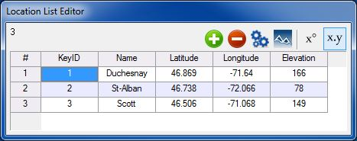
In the Location List Editor dialog, click the Add Point button three times and enter the names, coordinates and characteristics for three locations (for the purposes of this example, copy the relevant information from the figure on the right). Once you have entered all the information, click OK to save this new location list.

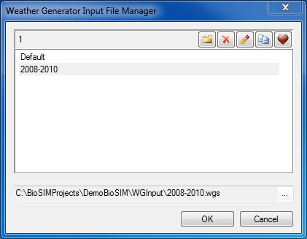
Click the Define WG Input button located at the far right of the Weather generator field to define the weather regime assembly parameters. Two dialogs will appear; the first dialog is the Weather Generator Input Editor while the second is the Weather Generator (WG) Parameters.

In the Weather Generator Input Editor dialog, click the New button and type in 2008-2010 as the name of the new set of parameter values to be defined. A new file with the name 2008-2010.tgs will be created in the \Model Input\ sub-directory of the project.
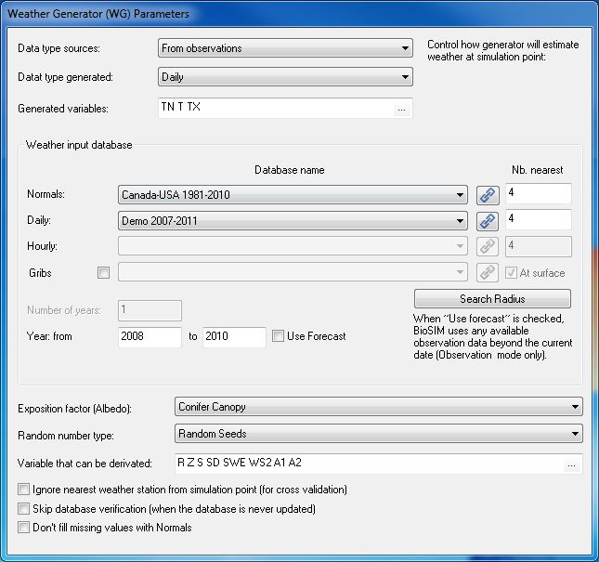
This will activate the Weather Generator (WG) Parameters dialog that allows you to modify the weather generator’s parameters.

For this example, you will be using real historical data and not stochastic disaggregation data obtained from Normals. Therefore, start by selecting the “Daily Data” radio button and then, select “Demo 2007-2011” from the drop-down list.

NOTE: If the “Demo 2007-2011” database is not available in the drop-down list, you must click on the Link a New File button and indicate to BioSIM where the database is.

By default, this database (Demo 2007-2011.DailyStations) is installed in the following \Weather\ sub-directory: “C:\Program Files\NRCan\Examples\DemoBioSIM\Weather\”.
Afterwards, type 2008 and 2010 in the First year and Last year fields, respectively.
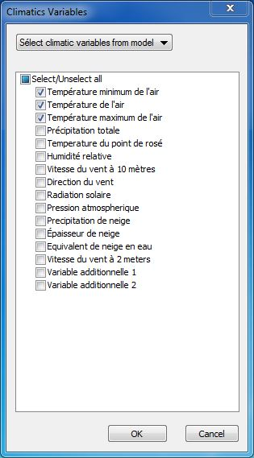
NOTE: Even if you choose “Daily data”, a Normals database must be selected (in this case Canada-USA 1981-2010) to fill any gaps in the daily data

You must choose the climate variables you want. In the generated variable field, click on «...» and select the model you want to simulate.
You will be using “DegreeDay (Annual)” in this example.

Leave all other fields to their default values and then click OK in the Weather Generator Input Editor dialog to accept these new parameter values.

You can now take a closer look at the weather stations that have been matched to the locations you have specified for this simulation.

Because this simulation is based on historical daily data (2008 to 2010), and because the “DegreeDay (Annual)” model is deterministic, there is no need to replicate the runs which means that, in this case, the value in the Replication field of the Simulation Editor dialog can be left at 1.

NOTE: The greyed field to the right of the Replication field always displays whether a model is stochastic or deterministic. Stochastic models usually require replication.

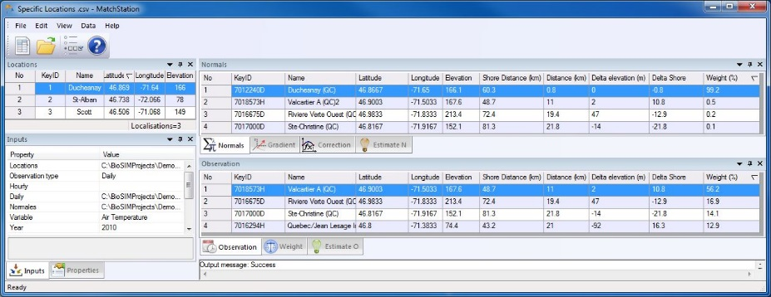
In the Project window, select the simulation “Example 1” and click the Show Matched Stations button  on the second row of the Project window’s toolbar, or select [Project] and then [Match Stations…] from the menu bar. This will open the Matches for Location List dialog.

When a location is selected in the left hand side list field, all drop-down lists and other list fields of the dialog are updated with the information concerning this location.

In the «Inputs» window, you can select the type of data (daily, hourty), weather variable, number of neighbors, year you want to see the stations.

The «Properties» window displays the coordinates and the elevation of the selected location.

The «Normals» window displays the information on the closest Normals stations matched to the selected location. While the «Observation» window displays the information on the closest Daily stations matched to the selected location. Please note that for a given location, Normals and observation stations matched may differ.

Both the Normals and Daily station list fields contain a column that displays the weight (%) each weather station has in generating weather data for the selected location (assuming there are no missing data). These weights are proportional to distance from the location.

Along with the distance and elevation columns can be useful in identifying errors in the specification of locations (e.g. positive longitude in the western hemisphere).

Step 3: Defining Model Execution
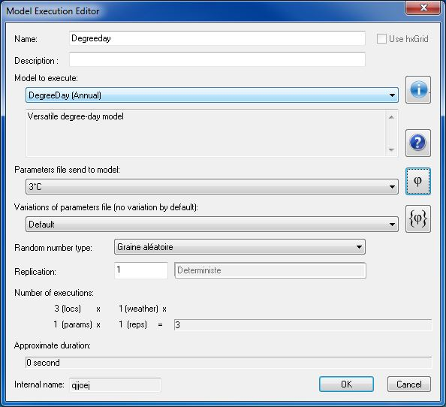
Select a weather generation (in this case, Example 1) to which you want to add an analysis and click the Add Model Execution button in the first row of the Project window’s toolbar, or select [Project] and then [Add Model Execution …] from the menu bar.

This will open the Model Execution Editor dialog, which a new simulation can be defined or an existing simulation can be edited.

Type Degreeday in the Name field, this name will appear in the Project window.

If you wish, you can type in a description of the simulation being defined in the Description field. This description will appear in the Execute Message Log window once the component has been executed.

Select the model you want to simulate. You will be using “DegreeDay (Annual)” in this example.

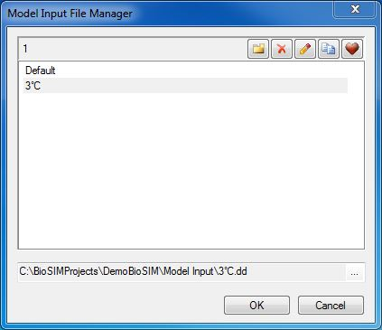
Click the Define Model Input button  located at the far right of the Model input field. Two dialogs will appear; the first dialog is the Model Input Editor and the second is a model specific dialog (in this case “DegreeDay (Annual)”) which varies with the model selected.
The number of model input (s).
The full path of the file

Click the New button in the Model Input Editor dialog and type in 3°C as the name of the new set of parameter values to be defined. A new file with the name 3°C.dd will be created in the \Model Input\ sub-directory of the project.

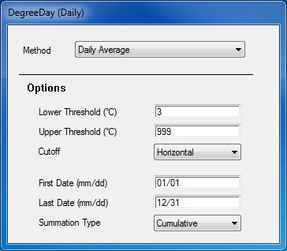

To edit the parameters of this new file, select it in the Model Input Editor dialog list field. For this example, type 3 in the Degree-day threshold field of the DegreeDay (Daily) dialog and then click OK in the Model Input Editor dialog to save your new parameters.

Step 4: Defining an analysis to interpret the results

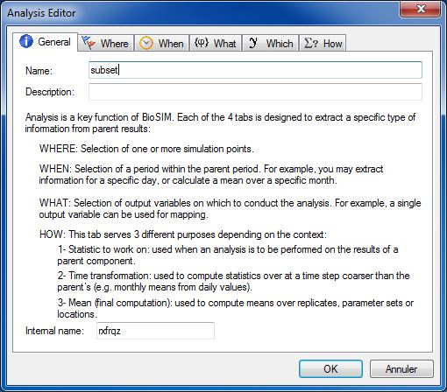
Select a weather generation (in this case, Example 1) to which you want to add an analysis and click the Add Analysis button in the first row of the Project window’s toolbar, or select [Project] and then [Add Analysis…] from the menu bar.

This will open the Analysis Editor dialog which is composed of 6 tabs: General, Where, When,What,which and How. For a complete description of each tab, please refer to the manual

In the General tab, type Subset in the Name field, this will be the name of your analysis (in the Project window).

You may also enter a useful description of the analysis to be performed (in the Description field) which you will be able to see in the Execute Message Log window.

In the Where tab, check the “Select a subset of locations” checkbox, this will open your location list and allow you to select one or more locations.

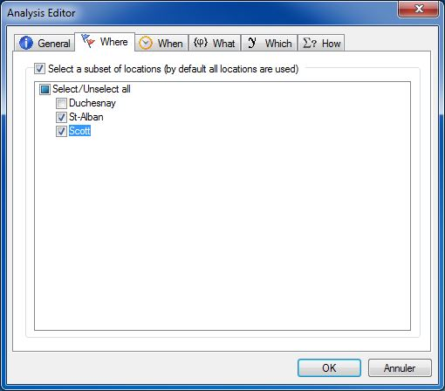
For this example, check the St-Alban and Scott locations.

In the When tab, check the “Select a period” checkbox and type 2008/04/01 in the Beginning field and 2009/08/31 in the End field.

Since the “Example 1” simulation covers the years 2008 to 2010, this will limit the period covered by the “Subset” analysis from April 1st 2008 to August 31st 2009.

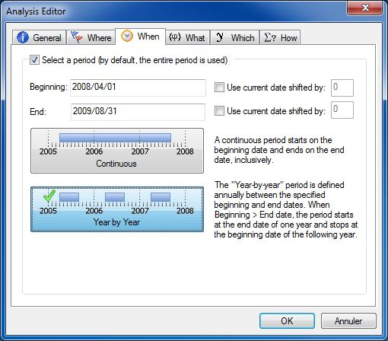
By default, the When tab is set for coverage of a “Continuous” time period using boundaries defined by the beginning and end dates entered in the appropriate fields. As a result, data from the entire period covered between the beginning and end dates are used by BioSIM to compute a single value.

Click the Year by Year button 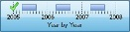. This will make BioSIM use data from the period covered between the beginning and end dates on a year by year basis. Thus, it will use the April 1st to August 31st periods for 2008 and 2009. Data outside the specified dates, year by year, will be disregarded during computation.
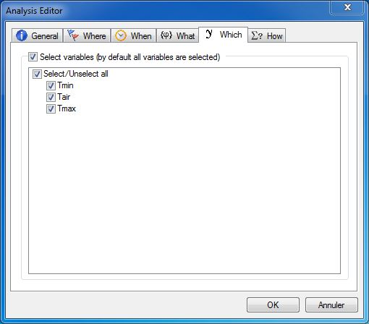
In the Which tab, check the “Select variables” checkbox and select the checkboxes of the variables you are interested in.

For this example, check Tmin, Tairand Tmax.

In the How tab, check the “Define time transformation” checkbox.
Then, select “Monthly” from the right hand side
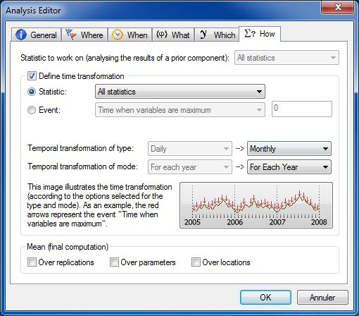
drop-down list of the Temporal transformation of type field and “For each year” from the right hand side drop-down list of the Temporal transformation of mode field.
Make sure that the default “Statistic” radio button is selected and that the drop-down list on the right is set to “All statistics”.
Uncheck the “Over replications” checkbox and then click OK to save the specifications entered for all tabs.

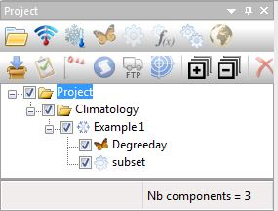
Before running the simulation and the analysis, make sure that the simulation “Example 1” and the analysis “Subset” checkboxes are checked in the Project window. Then, click the Execute Checked button on the main window’s toolbar, or select [Project] and then [Execute Checked] from the menu bar.

The BioSIM progress bar will briefly appear before the results become visible in the Data tab of the main window.

Please note that when the Execute Checked button is clicked, results are created/updated for all checked components of the project.

To view the results:

Select the “Subset” analysis in the Project window. The numerical results for this analysis can be viewed in the Data tab located to the left at the bottom of the main window. The main window is composed of two tabs: the Data tab which contains model output in tabular form, and the Graph tab, which allows you to create graphs.

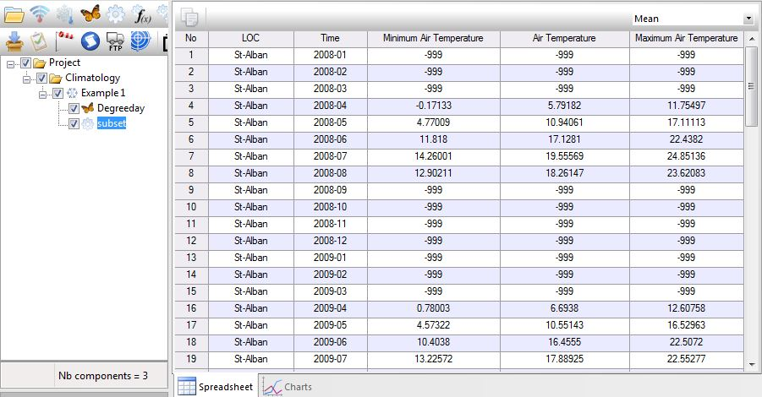
The drop-down list you see in the upper right corner of the main window allows you to choose the statistic for which you want to view the current results in the Data tab.
BioSIM always shows the child component’s results in the temporal format (all years) of the parent component. Therefore, missing values (-999) are used to fill the cells that were outside the desired period for the child component.

For example, if you select “Nb Values”, you will be able to see how many values were used to calculate the statistics.

Step 5: Adding a component onto another component

In the Project window, select the “Subset” analysis and add a new analysis to it by clicking the Add Analysis button. This will open the Analysis Editor dialog.

In the General tab, type Sum of precipitation in the Name field.

For this example, there is no need to modify anything in the Where, When, what and which tabs.

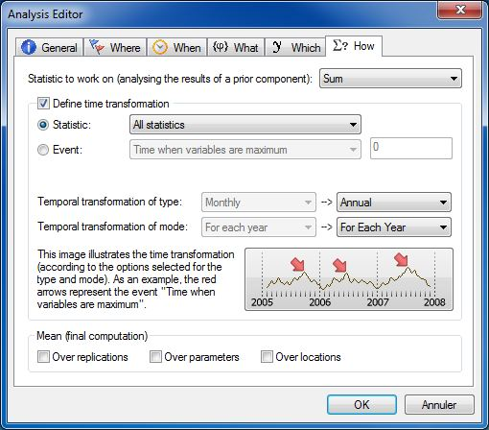
In the How tab, select “Sum” from the drop-down list to the right of the Statistic to work on field. This will instruct BioSIM to use the sum among the results of the parent analysis.

Check the “Define time transformation” checkbox to activate the right hand side drop-down lists of the Temporal transformation of type and Temporal transformation of mode fields and select “Annual” and “For each year” respectively.

Make sure that the default “Statistic” radio button is selected and that the drop-down list on the right is set to “All statistics”.

Uncheck the “Over replications” checkbox and then click OK to save the specifications entered for all tabs.

Before running this new analysis, uncheck the simulation “Example 1” and the previous analysis “Subset” because they have already been executed and it is not necessary to run them again.

To select only the analysis you are interested in executing, hold down CTRL and uncheck the parent simulation “Example 1” and the parent analysis “Subset” checkboxes (next to the component in the Project window). Make sure that the new analysis “Sum of precipitation” checkbox is checked and then click the Execute Checked button on the main window’s toolbar, or select [Project] and then [Execute Checked] from the menu bar.

The BioSIM progress bar will appear briefly.

Understanding these new results:
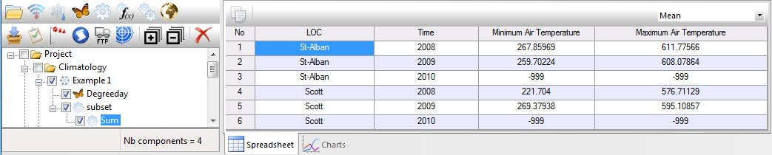
Normally, you would expect the results being displayed in the main window’s Data tab for this new analysis to be the Air Temperature (April to August) per year for each location. However, by default, BioSIM shows you the mean. Therefore; you are looking at the mean of the total monthly precipitation. Always keep in mind that you must choose the statistic you are interested in viewing in the upper right corner drop-down list when looking at the results.

To see the total sum of monthly precipitation, select Sum in the drop-down list.

Step 6: Exporting the results

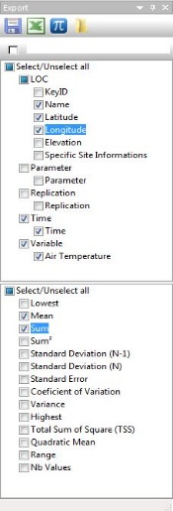
To export the results of your analysis, select the columns you want to export in the upper list field of the Export window; in this example, check Name, Latitude, Longitude, Time and Air Temperature. You must also select the statistics you want to export from the scroll down menu in the lower list field of the Export window; in this case, choose Mean and Sum.

The To Spreadsheet button allows you to export the results as a CSV file in the \Output\ sub-directory and simultaneously open it in the spreadsheet of your choice (e.g. Excel).
Send the results of the current component outside To Calc (spreadsheet for OpenOffice)

Try sending this export to your spreadsheet software now.

If BioSIM is unable to find the spreadsheet software on your computer, a dialog will appear allowing you to browse and indicate to BioSIM where to find it.

NOTE: If you do not specify a name in the File name field of the Export window by default, BioSIM will assign the component’s name to the export file, in this case, “Export (Sum).csv”.

3 Example 2
The objective of the second example is to show you how to extract an event from a Phenology model.

Step 1: Defining a new group of components
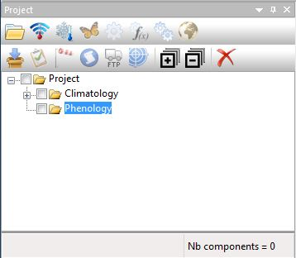
Reminder: To add a component into another, select the parent component and then, click the appropriate button in the toolbar’s first row to add a child component to it.
In this second example, we will skip over certain steps explained earlier. If you do not remember how to proceed, please refer to the previous example.

Select the main group called “Project” in the Project window and add a new group to it (). Rename this group Phenology.

Step 2: Defining a new simulation
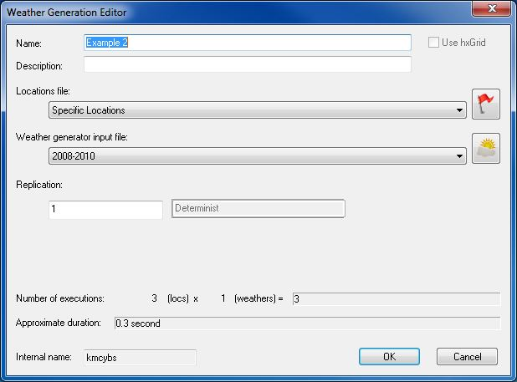
Select the “Phenology” group you just created and click the Add Weather Generation button on the first row of the Project window’s toolbar, or select [Project] and then [Add Weather Generation] from the menu bar.

This will open the Weather Generation Editor dialog with which a new Weather Generation can be defined.

Type Example 2 in the Name field, this name will appear in the Project window. Because you have already defined a WG Input parameter set in the previous example (2008-2010), you can now select it directly in the drop-down list next to the Weather generator field and use it in this example.

Select “Specific Locations” from the drop-down list next to the Location list field (also defined in the previous example).

NOTE: if a modification is made to the input parameters of a model, a weather generator or a location list set, all simulations using these sets will use the new set of parameters at the next execution. Therefore, if you want to keep your original input parameters for a given simulation, you must create a new set of input parameters for each new simulation.

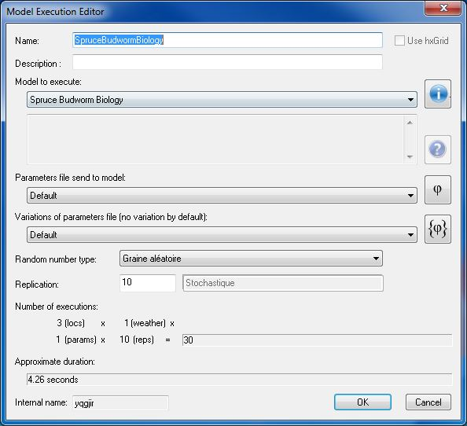
Select a weather generation (in this case, Example 2) to which you want to add an model and click the Add Model Execution button in the first row of the Project window’s toolbar, or select [Project] and then [Add Model Execution …] from the menu bar.

In the Model Execution Editor dialog, type Spruce Budworm Biology in the Name field and select “Spruce Budworm Biology” from the drop-down list next to the Model field. This is the simulation model you will be using in this example.

You will be using the default values for the parameters of the “Spruce Budworm Biology” model; therefore, the Model field’s drop-down list can be left on “Default”.

Although this simulation is based on historical daily data (2008-2010), because the “Spruce Budworm Biology” model is stochastic, you need to replicate the runs. Type 10 in the Replication field.

This completes the specifications of the new simulation. Click OK to save the current settings and return to the main BioSIM window.

Step 3: Defining an average output analysis
Select a “Spruce Budworm Biology” Model Execution and add an analysis to it ().

In the General tab of the Analysis Editor dialog, type Average Output in the Name field, leave all other tabs (Where, When, What, Which and How) on their default parameters and click OK to save your new analysis.

NOTE: An average output analysis is used to compute means over replications.

Step 4: Defining and running an event extraction analysis
Select the “Spruce Budworm Biology” Model Execution again and add another analysis to it ().

In the General tab of the Analysis Editor dialog, type Date of Peaks in the Name field.

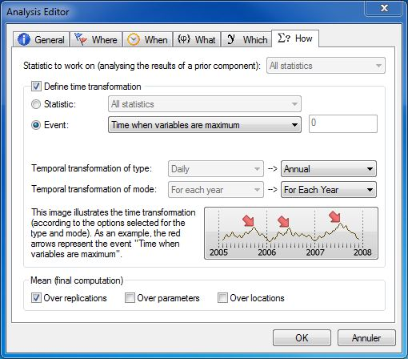
Leave the Where, When, What tabs to their default settings.

In the Which tab, check the “Select variables” checkbox and then, check L3, L4, L5 and L6.

In the How tab, define the event to be extracted from the results of the parent component (the Example 2 simulation).

NOTE: The greyed left hand side drop-down lists of the Temporal transformation of type and Temporal transformation of mode fields display the output time format of the parent component.

Check the “Define time transformation” checkbox and select the “Event” radio button. This will activate the drop-down list and allow you to select the event type you want to analyse.

For this analysis, you want BioSIM to determine the day when the variables (i.e., frequencies of 3rd, 4th, 5th and 6th instars) are at their maximum which means you need to select “Time when variables are maximum” from the drop-down list.

Step 6: Running the checked components

Before running this new analysis, make sure that the “Climatology” group and all of its components are unchecked because they have already been executed and it is not necessary to run them again. Then, Execute () your project for a second time (all “Phenology” group components).

You will see the BioSIM progress bar briefly before the results appear in the Data tab of the main window.

NOTE: The current number of checked components is always displayed in the bottom right corner of the Project window (Nb runs =).

Interpreting the results:

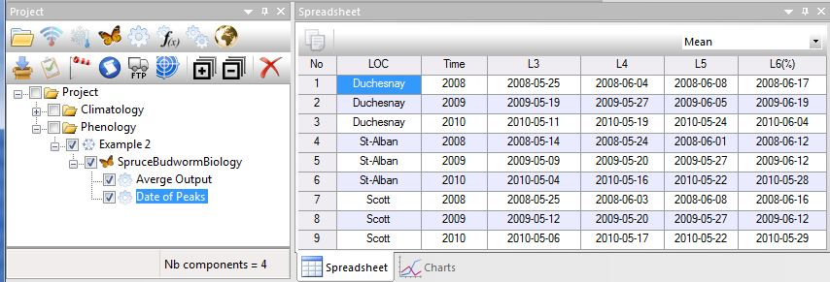
1- “Date of Peaks” analysis:

The results represent the dates when each larval stage should be at its maximum for each year at each location.

NOTE: Make sure that the statistic you are looking at is “Mean”.

You can modify the date format in the Region page of the Options dialog (see the manual for details)

2- “Average Output” analysis:

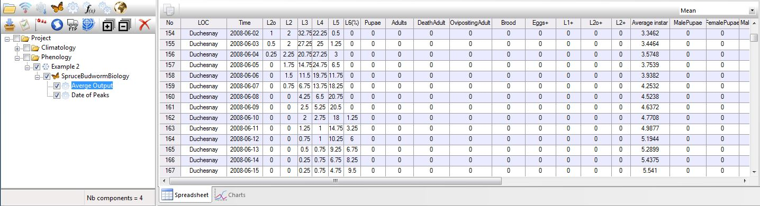
The results represent the average of the 10 replications for the frequency of each larval stage for each day of each year for all locations.

Step 7: Adding a graph
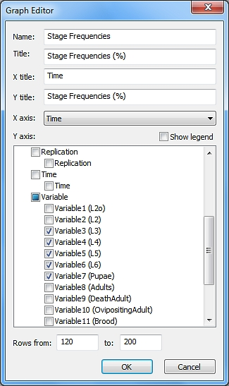
First and last rows used to create the graph.
Select the “Average Output” analysis in the Project window. Click the Graph tab and then the Add Graph button respectively located in the lower and upper left corners of BioSIM’s main window.

The Graph Editor dialog will appear. Type Stage Frequencies in the Name field, Stage Frequencies (%) in the Title field, Time in the X Title field, Stage Frequencies (%) in the Y Title field and select the variable “Time” from the drop-down list in the X axis field.

Check the Variable3 (L3), Variable4 (L4), Variable5 (L5), Variable6 (L6) and Variable7 (Pupae) checkboxes in the Y axis list field.

If you want the legend to appear next to your graph, you have to check the “Show legend” checkbox.

BioSIM does not graph data according to location; it does so according to the row numbers you enter in the edit boxes of the Rows from and to field.

For instance, if you wanted to graph all locations for all years in this example, BioSIM would create a graph but would not separate the data for each location therefore, points from all locations would be treated together (per variable/column) and the graph would not be very useful.

When creating a graph in BioSIM you need to decide beforehand what you want to graph and you must change the numbers in the Rows from and to field accordingly.

For the purposes of this example, type 120 in the left edit box and 200 in the right edit box of the Rows from and to field, these numbers refer to the rows of the Data tab you want to use to create your graph. In this example for instance, you will be looking at data from the first location (Duchesnay) from the end of April to the middle of July for the first year (2008) covered by the analysis. This means that if you want to create a graph for another location, another year, different months, etc., you must change the numbers in the Rows from and to field accordingly.

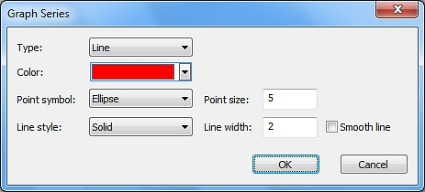
You can choose each variable’s point/line properties by double clicking on any Y variable in the Y axis list field. This will open the Graph Series dialog and allow you to modify the attributes of the variable in question. Click OK to save any modifications.

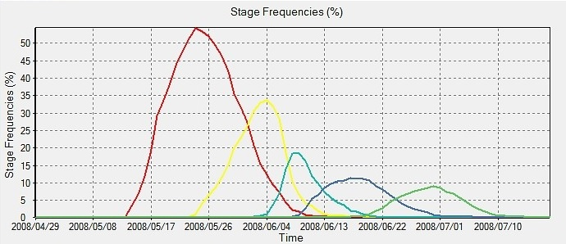
When all fields and parameter values have been defined, click OK to save your graph. Your graph will now be displayed in the Graph tab.

If you want to create another graph from the same results but with different parameters, you can do so by clicking the Add Graph button again.

All the graphs of a component can be accessed in the drop-down list in the upper right corner of the Graph tab.

It is possible to zoom in on part of the graph by clicking on your mouse and then dragging it from left to right and encompassing the region of the graph you want to zoom in on.

You can zoom back out to the original view by dragging the mouse from right to left (a small movement will suffice).

4 Example 3: Mapping

Step 1: Defining a Weather Execution and Model Execution

In the Project window, select the “Climatology” group and click the Add Weather Generation button on the first row of the Project window’s toolbar, or select [Project] and then [Add Weather Generation] from the menu bar.

Leave the Weather generator Input fields’ drop-down lists on “Default” (the weather generator will use the Canada-USA 1981-2010 Normals database as default).

Click the Define Location List button () on the right hand side of the Locations File field in the Weather Generation Editor dialog.

Then, click the New button in the Location File Editor dialog and type in Random Locations as the name of your new location list. A new file with the name Random Locations.csv will be created in the \Loc\ sub-directory of the project.

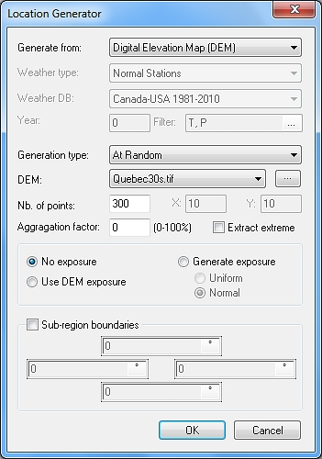
In the Location List Editor dialog, click the Generate button to open the Location Generator dialog which can generate points from weather stations or DEM’s.

In this dialog, select “Digital Elevation Map (DEM)” in the drop-down list of the Generate from field and “At Random” in the drop-down list of the Generation type field.

In the DEM field’s drop-down list, select “Quebec30s.tif” (this DEM of Quebec comes with BioSIM).

NOTE: If you want to use a different DEM you can link it to BioSIM with the browse button to the right of the DEM field’s drop-down list. This will open the Linked Data Editor dialog at the Input Maps tab where you can link a new map by clicking on the Link New File button .

In the Nb. of points field, type 300 and click OK. Please refer to the manual for guidelines concerning the minimum number of points required.

The BioSIM progress bar will briefly appear. This will generate a list of 300 random locations (and their elevations) from the input DEM Quebec30s.tif. Click OK in the Location File Editor dialog to save your new “Random Locations” list.

Because these simulations are based on Normals (as defined earlier by selecting “Default” in the Weather generator field of the Simulation Editor dialog) weather will be stochastic. Thus, you need to replicate the runs. As an adequate amount of replications, type 10 in the Replication field of the Simulation Editor dialog. Please refer to the manual for guidelines concerning the minimum number of replications required.

Select a weather generation « Example 3» to which you want to add an Model and click the Add Model Execution button in the first row of the Project window’s toolbar, or select [Project] and then [Add Model Execution …] from the menu bar.

In the Model Execution Editor dialog, type Degreeday in the Name field and select “DegreeDay(Annual)” from the Model field’s drop-down list (this is the model that you will be using in this example).

You have now defined all your simulation parameters, click OK to save the current settings and return to the main BioSIM window.

Step 2: Defining a subset analysis

Select the Model “Degreeday” and add an Analysis to it ().

In the General tab of the Analysis Editor dialog, type DD in the Name field.

In the Which tab, check the “Select variables” checkbox. Then, check the “DegreeDay” variables and click OK to save these parameters (leave all other tabs on their default parameters).

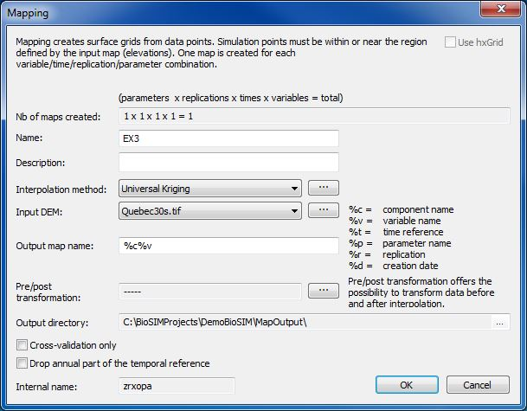
Step 3: Defining a mapping

Select the analysis “DD” you just created and click the Add Mapping button in the first row of the Project window’s toolbar or select [Project] and then [Add Mapping…] from the menu bar. This will open the Mapping dialog.

The Nb of maps created field (greyed) shows the final number of maps that will be created from the parent component (the “DD” analysis). In this case, 1 maps will be created: 1 variables X 1 year X 1 parameter set.

In the Name field, type Ex 3.

The Description field allows you to enter a useful description of the mapping to be performed.

Select “Universal Kriging” from the drop-down list next to the Interpolation method field.

Select “Quebec30s.tif” (same map from which your random locations list was extracted) from the drop-down list next to the Input DEM field.

BioSIM uses an automatic scheme based on time (%t), parameter (%p), component (%c) and variable (%v) references to name output maps with minimal need for user input. The user can choose the information and specify the format used to name output maps. In the Output map name field, keep “%c%v”, delete %t and add parentheses around the %v then, click OK.

Because you chose to keep “%c(%v)” in the Output map name field, the name of the output map file will include the component name followed by the name of the variable in parenthesis (e.g. Ex 3(DegreeDay).tif ).

Since the temporal dimension of the parent component of this mapping example is 1, and no parameter variation was used, you do not have to specify the temporal reference (%t) or the parameter reference (%p) in the output map name.

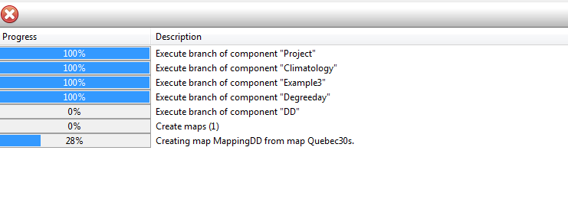
Step 4: Run All

Uncheck all Project components except the current weather generation (Example 3), Model Execution(Degreeday), analysis (DD) and mapping (EX 3) then, Execute () your project a third time.

The BioSIM progress bar will appear in the Job in Progress dialog and allow you to see the progress of the various simulation tasks (a total of 300 locations x 10 replicates = 3000 model runs).

Afterwards, BioSIM will execute the analysis, optimise the Kriging parameters and create the output map(s). Please note that this can take several hours, depending on the number of model runs, the size of the map, and the machine being used.

The results will be shown in the Data tab of the main window.

Step 5: Viewing the R² cross-validation results

You can see the cross-validation results (R² values: goodness of fit between model output and the map) of the spatial interpolation (Universal Kriging) in the Execute Message Log window.

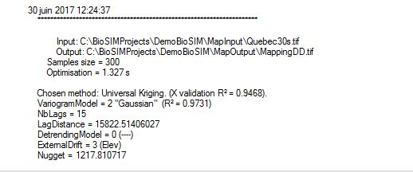

In this example the cross-validation R² for mapping DegreeDay was 0.9468, very high.

Step 6: Viewing the maps

In the Project window, right click on the mapping component “Ex 3” and select “Show Output Map(s)” in the pop-up menu that appears. This will send the event map to the ShowMap software.

If you want to see the locations on the map, you can right click again and select “Show Locations”. ShowMap is a very user-friendly, powerful and fast geographic information display program, the use of which is beyond the scope of this tutorial.

With a few minor modifications in ShowMap, you can easily obtain a map resembling this image from one of the basic maps you just created.

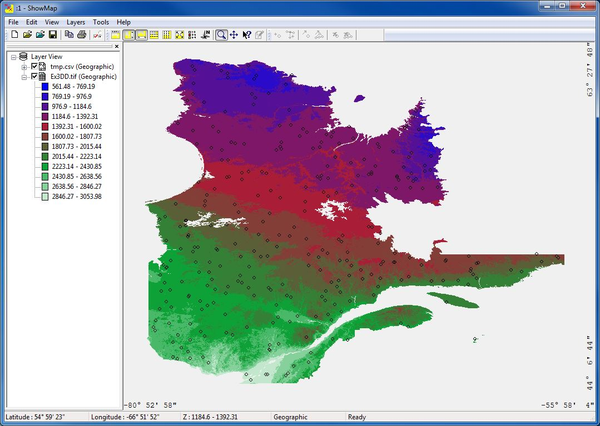

5 Example 4: Update current daily database

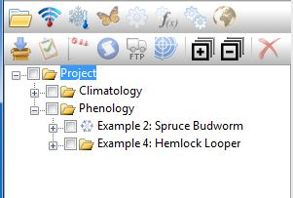
Step 1: Adding a new Subgroup of components
In the Project window, select the “Phenology” folder icon and then click the Add Group button on the first row of the Project window’s toolbar, or select [Project] and then [Add Group] from the menu bar. This will add a group to the “Project”.

Select the “Group” component you just created, click on it a second time and rename this group Example 4: Hemlock Looper.

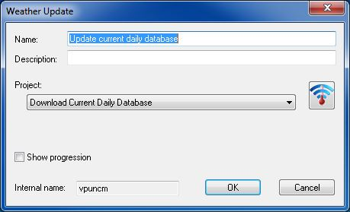
Step 2: Defining a Update weather data
Select the “Example 4: Hemlock looper” group you just created and click the Add Update weather data button on the first row of the Project window’s toolbar, or select [Project] and then [Add Update weather…] from the menu bar.
Click button to open WeatherUpdater application and choose parameters for the update.
This will open the Weather Generation Editor dialog with which a new Weather Generation can be defined.

Type Update current daily database in the Name field, this name will appear in the Project window.

Select “Download Current Daily Database” from the drop-down list next to the Project list field.

Before running updater weather database, make sure that the Update current daily database checkbox is checked in the Project window. Then, click the Execute Checked button on the main window, or select [Project] and then [Execute Checked] from the menu bar.

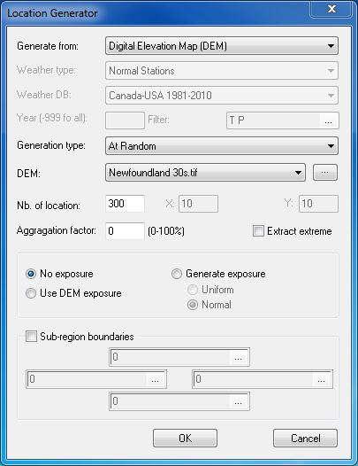
Step 3: Defining a weather generation and model execution
Select the “Example 4: Hemlock looper” group and click the Add a weather generator button, type "Current Weather" in the name, as in the preceding examples.

In the localization file we will create a new one, as in example 3, we will name "Newfoundland".

Click the Define WG Input button located at the far right of the Weather generator field to define the weather regime assembly parameters. Two dialogs will appear; the first dialog is the Weather Generator Input Editor while the second is the Weather Generator (WG) Parameters.
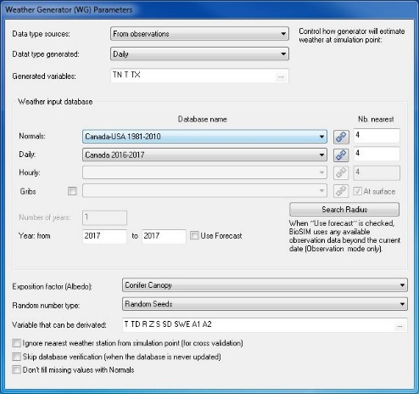
In the Weather Generator Input Editor dialog, click the New button and type in Current as the name.
You choose “From observations” in the data type Sources.
In weather input database choose “Canada 2016-2017” in the Daily, and 2017 to 2017 for year.
Keep default all other parameters and click OK to save.
Type 10 in Replication and click OK to save.

Select a weather generation (Current weather) and click the Add Model Execution button.
Type HemlockLooper in the Name field, this name will appear in the Project window.

Select the model you want to simulate. You will be using “HemlockLooper” in this example.
Leave all others parameters in default and click OK to save.

Step 4: Defining an output analysis
As in the previous examples on add an analysis.

In the General tab of the Analysis Editor dialog, type Analysis in the Name field.
Leave the Where, When, What tabs to their default settings.
In the Which tab, check the “Select variables” checkbox and then, check L3, L4 and Pupae.
In the How tab, check the “Define time transformation” checkbox and select the “Event” radio button. Select “Time when variables are maximum” from the drop-down list and click OK to save.

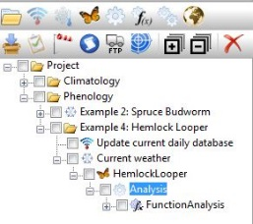

Step 5: Defining an function Analysis
Select an analysis (in this case, Analysis) to which you want to add a function analysis and click the Add Model function analysis button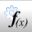.
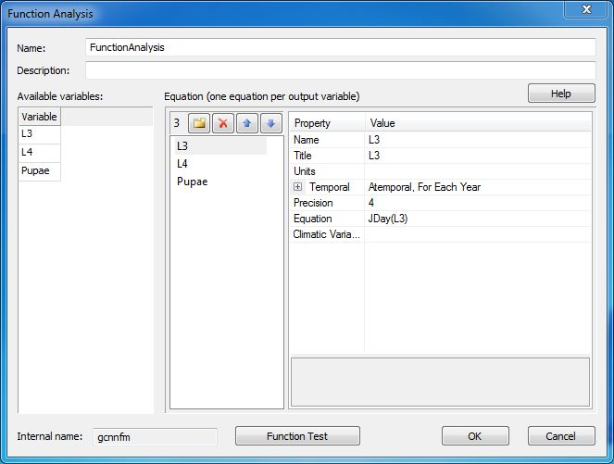
Type JDay in the Name field, this name will appear in the Project window.
Double-click the available variables to move them to Equation.
For each variable add JDay in the equation and change temporal type to Atemporal (JDay function convert date normal to Julian day number, click Help button for more function and detail).

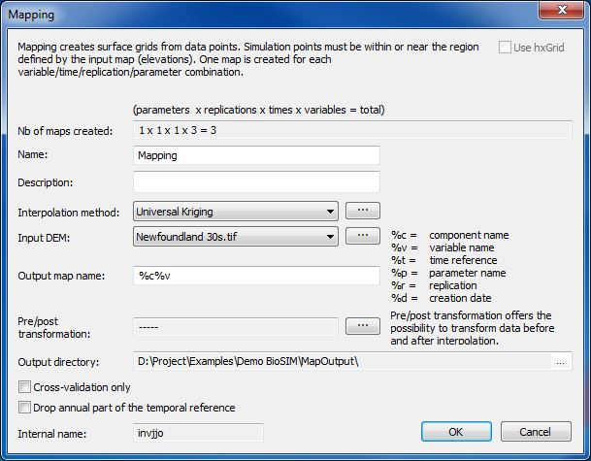

Step 6: Defining a mapping
In this step we will follow the same procedure as in example 3 step 3, select a “Newfoundlamd 30S.tif” from the drop-down list next to the Input DEM field.

Step 7: Run and Viewing the maps
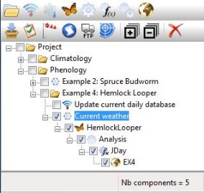
Uncheck all Project components except the current weather generation (Current weather), Model Execution(HemlockLooper), analysis (Analysis), function analysis(JDay) and mapping (EX) then, Execute () your project.

The results will be shown in the Data tab of the main window.

Viewing the maps:

As in the example 3, right click on the mapping component “Mapping” and select “Show Output Map(s)” in the pop-up menu that appears. This will send the event map to the ShowMap software.

If you want to see the locations on the map, you can right click again and select “Show Locations”.

